DATABASE PROJECT REPORT

BRANDON DOOLEY

#16327446

TRINITY COLLEGE DUBLIN

**Introduction**

As part of the CS3041 Information Management database design project I decided to model a database representing the top 10 teams in the Barclays Premier League as of Thursday the 1st November 2018.

The relational tables that I chose to model are as follows:

* Fixtures
* Managers
* Players
* Stadiums
* Teams
* Transfers

Within the database I modelled all fixtures from Sunday 11th up to Saturday the 8th of December. This was done to allow for me to continuously input the results of these fixtures into the database in order to demonstrate the use of my designed triggers and the effect they have on other relations within the database.

Within the players table I modelled five players from each of the teams including a goalkeeper, defender, midfielder and two forwards for each team. The data regarding stadiums and managers is valid as of Sunday 11th of November.

All data regarding transfers is fictional and does not represent any real transfer that has occurred in the premier league within this period. They also solely serve the purpose of demonstrating the use of the designed triggers and their respective effects.

**Entity Relationship Diagram**

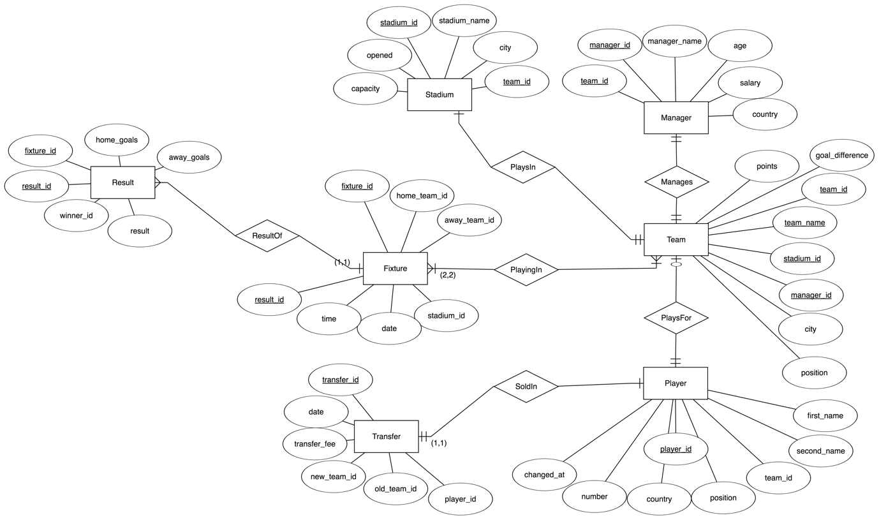

**Relational Schema Diagram**

